SESSION-1
Q-1: Install MySQL Community Server on your computer and take a screenshot of the MySQL installer completion window.
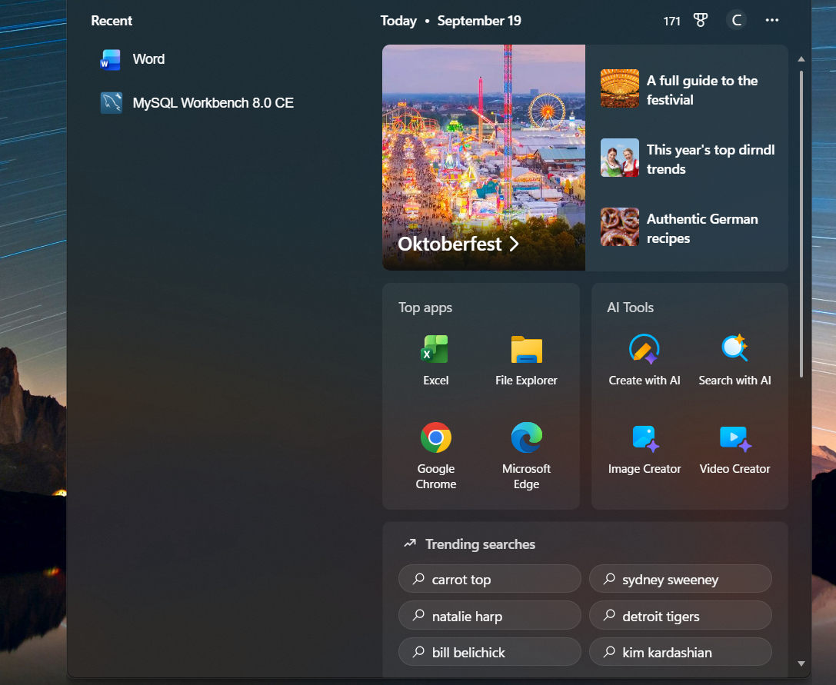

Q-2 : Open MySQL Workbench or DB Browser, connect to your local MySQL server, and create a new database called
CREATE DATABASE music_streaming_db;

Q-3 : SQL command to create a new database named food_delivery_db:
CREATE DATABASE food_delivery_db;

Q-4: Differences between MySQL and PostgreSQL
Feature/Use Case | MySQL | PostgreSQL
Performance | Optimized for read-heavy workloads and web applications | Better for complex queries and write-heavy workloads
Data Types & Features | Limited advanced data types, simpler feature set | Rich support for advanced data types (JSON, arrays, hstore) and complex indexing
ACID Compliance | Provides ACID compliance but less strict in certain configurations | Fully ACID-compliant with strong emphasis on reliability and consistency
Examples of usage:
- MySQL: Used by Facebook for certain backend services.
- PostgreSQL: Used by Instagram for handling complex data operations.

